*************************26 NOV*******************************

1. 1.Select department name & location of all the employees working for CLARK.
2. Select all the departmental information for all the managers
3. Display the first maximum salary.
4. Display the second maximum salary.
5. Display the third maximum salary.
6. Display all the managers & clerks who work in Accounts and Marketing departments.
7. Display all the salesmen who are not located at DALLAS.

***Answers :***

1. SELECT DNAME , LOC FROM DEPT WHERE DEPTNO=(SELECT DEPTNO FROM EMP WHERE EMPNO=(SELECT MGR FROM EMP WHERE ENAME ='CLARK'))

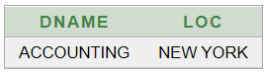

2.SELECT * FROM EMP E , DEPT D WHERE E.DEPTNO = D.DEPTNO AND JOB='MANAGER' ORDER BY E.DEPTNO

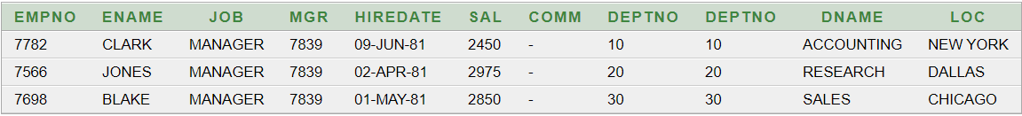

3.SELECT MAX(SAL) FROM EMP

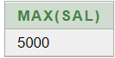

4. SELECT MAX(SAL) AS "SECOND MAX SAL" FROM EMP WHERE SAL<(SELECT MAX(SAL) FROM EMP)

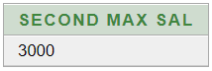

5. SELECT MAX(SAL) AS "THIRD MAX SAL" FROM EMP WHERE SAL<(SELECT MAX(SAL) FROM EMP WHERE SAL< (SELECT MAX(SAL) FROM EMP))

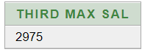

6 SELECT * FROM EMP WHERE JOB IN ('MANAGER','CLERK') AND DEPTNO IN (SELECT DEPTNO FROM DEPT WHERE DNAME IN ('ACCOUNTING','SALES'))

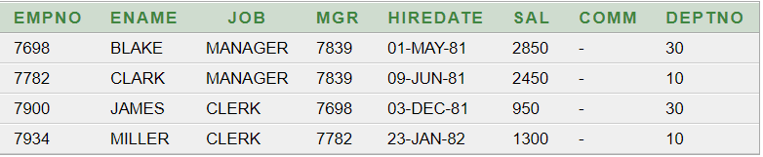

7SELECT * FROM EMP WHERE JOB='SALESMAN' AND DEPTNO IN (SELECT DEPTNO FROM DEPT WHERE LOC NOT IN 'DALLAS')

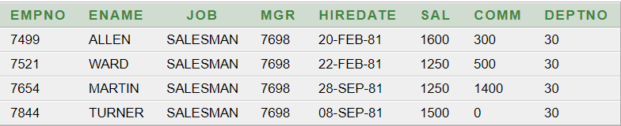

**#########################29NOV###########################**

1.Display all the managers & clerks who work in Accounts and Marketing departments.   
2.Display all the salesmen who are not located at DALLAS.

3.Select department name & location of all the employees working for CLARK.

4.Display all the departmental information for all the existing employees and if a department has no employees display it as “No employees”.

5.Get all the matching & non-matching records from both the tables.

6.Get all the employees who work in the same departments as of SCOTT

7.Display all the employees who have joined before their managers.

8.List all the employees who are earning more than their managers

***ANSWERS:***

1.SELECT * FROM EMP, DEPT WHERE (EMP.JOB IN'MANAGER' OR EMP.JOB IN'CLERK') AND (DEPT.DNAME IN'ACCOUNTING' OR DEPT.DNAME IN'SALES') AND EMP.DEPTNO=DEPT.DEPTNO

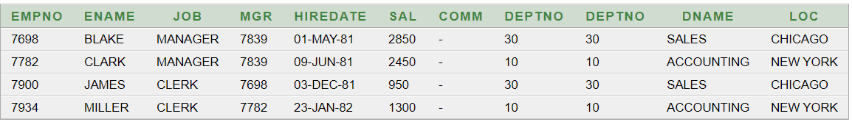

2. SELECT * FROM EMP , DEPT WHERE EMP.JOB IN 'SALESMAN' AND DEPT.LOC NOT IN 'DALLAS' AND EMP.DEPTNO=DEPT.DEPTNO

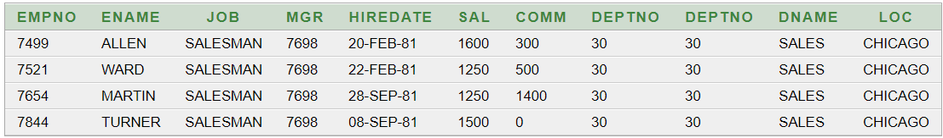

3.SELECT DEPT.DNAME , DEPT.LOC FROM EMP , DEPT WHERE EMP.MGR=(SELECT EMPNO FROM EMP WHERE ENAME='CLARK') AND EMP.DEPTNO=DEPT.DEPTNO

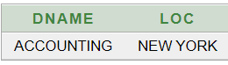

4. SELECT E.EMPNO,NVL(E.ENAME,'NO EMPLOYEES'),E.JOB,E.MGR , E.HIREDATE , E.SAL , E.COMM , E.DEPTNO, D.DNAME,D.LOC FROM EMP E , DEPT D WHERE E.DEPTNO(+) = D.DEPTNO

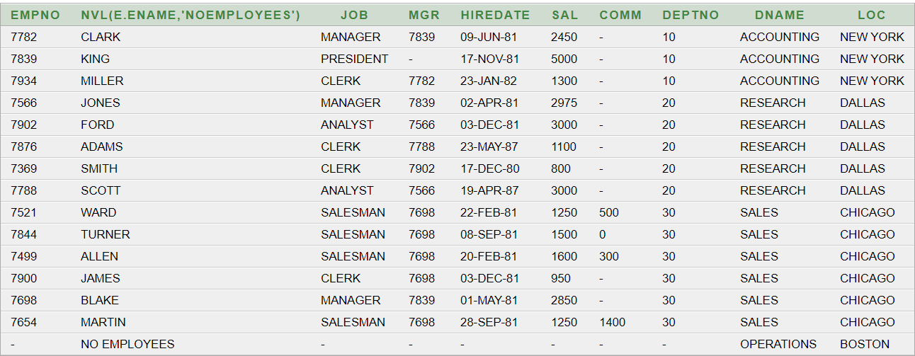

5. SELECT * FROM EMP ,DEPT WHERE EMP.DEPTNO(+) = DEPT.DEPTNO

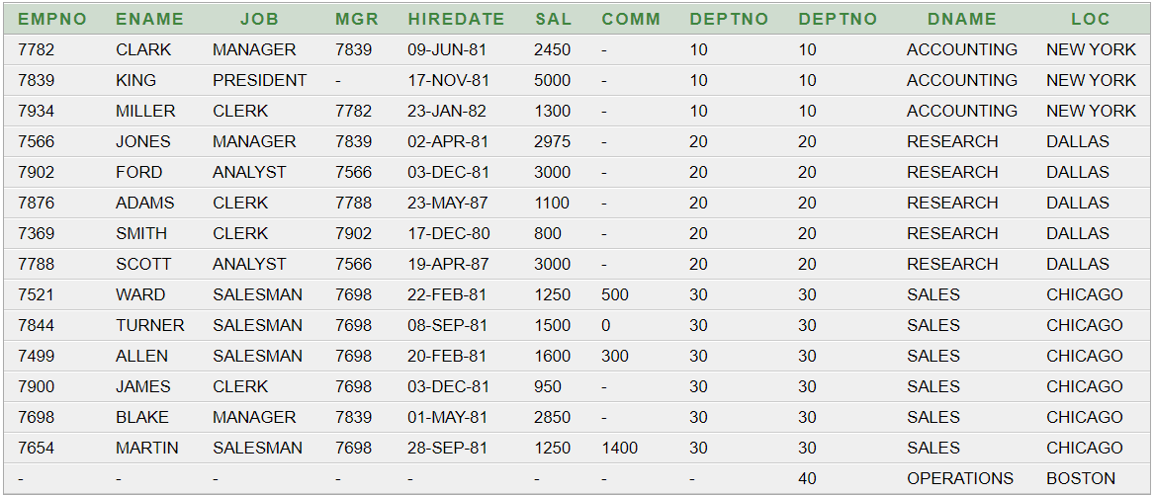

6. SELECT * FROM EMP ,DEPT WHERE DEPT.DNAME=(SELECT DEPT.DNAME FROM EMP ,DEPT WHERE EMP.ENAME='SCOTT' AND EMP.DEPTNO=DEPT.DEPTNO) AND EMP.DEPTNO=DEPT.DEPTNO

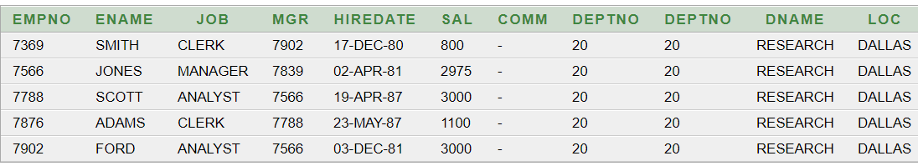

7. SELECT DISTINCT * FROM EMP E INNER JOIN EMP M ON E.MGR = M.EMPNO AND E.HIREDATE < M.HIREDAT

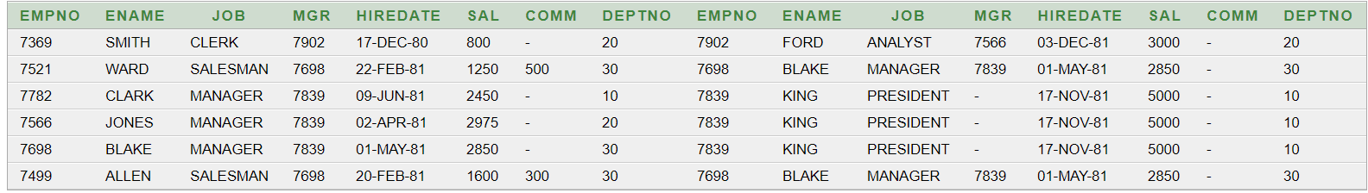

8. SELECT W.ENAME "Employee Name", W.SAL "Employee Salary", M.ENAME "Manager Name",M.SAL "Manager Salary" FROM EMP W,EMP M WHERE W.MGR=M.EMPNO AND W.SAL>M.SAL

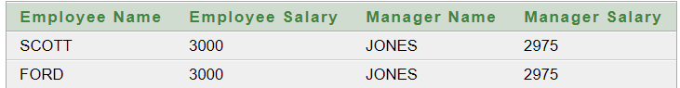

**TABLE :1**

|  |  |  |  |  |  |
| --- | --- | --- | --- | --- | --- |
| **SID** | **SNAME** | **ADDRESS** | **TID** | **TNAME** | **SKILL** |
| **101** | **GOCU** | **DHAKA** | **102** | **ROCU** | |  | | --- | | **VALORANT** | | **CSGO** | |

**AFTER NF 1 :-**

|  |  |  |  |  |  |
| --- | --- | --- | --- | --- | --- |
| **SID** | **SNAME** | **ADDRESS** | **TID** | **TNAME** | **SKILL** |
| **101** | **GOCU** | **DHAKA** | **102** | **ROCU** | **VALORANT** |
| **101** | **GOCU** | **DHAKA** | **102** | **ROCU** | **CSGO** |

**AFTER NF2:-**

**1.**

|  |  |  |
| --- | --- | --- |
| **SID** | **SNAME** | **ADDRESS** |
| **101** | **GOCU** | **DHAKA** |

**2.**

|  |  |  |  |
| --- | --- | --- | --- |
| **SID** | **TID** | **TNAME** | **SKILL** |
| **101** | **102** | **ROCU** | **VALORANT** |
| **101** | **102** | **ROCU** | **CSGO** |

**2.1**

|  |  |  |
| --- | --- | --- |
| **TID** | **TNAME** | **SKILL** |
| **102** | **ROCU** | **VALORANT** |
| **102** | **ROCU** | **CSGO** |

**2.2**

|  |  |
| --- | --- |
| **SID** | **TID** |
| **101** | **102** |

**TABLE : 2**

|  |  |  |  |  |  |
| --- | --- | --- | --- | --- | --- |
| **SID** | **SNAME** | **ADDRESS** | **DID** | **DNAME** | **PHONE** |
| **101** | **GOCU** | **DHAKA** | **103** | **GAME** | |  | | --- | | **1234** | | **1235** | |

**AFTER NF1:-**

|  |  |  |  |  |  |
| --- | --- | --- | --- | --- | --- |
| **SID** | **SNAME** | **ADDRESS** | **DID** | **DNAME** | **PHONE** |
| **101** | **GOCU** | **DHAKA** | **103** | **GAME** | **1234** |
| **101** | **GOCU** | **DHAKA** | **103** | **GAME** | **1235** |

**AFTER NF2:**

**1.**

|  |  |  |
| --- | --- | --- |
| **SID** | **SNAME** | **ADDRESS** |
| **101** | **GOCU** | **DHAKA** |

**2.**

|  |  |  |  |
| --- | --- | --- | --- |
| **SID** | **DID** | **DNAME** | **PHONE** |
| **101** | **103** | **GAME** | **1234** |
| **101** | **103** | **GAME** | **1235** |

**2.1**

|  |  |  |
| --- | --- | --- |
| **DID** | **DNAME** | **PHONE** |
| **103** | **GAME** | **1234** |
| **103** | **GAME** | **1235** |

**2.2**

|  |  |
| --- | --- |
| **SID** | **DID** |
| **101** | **103** |